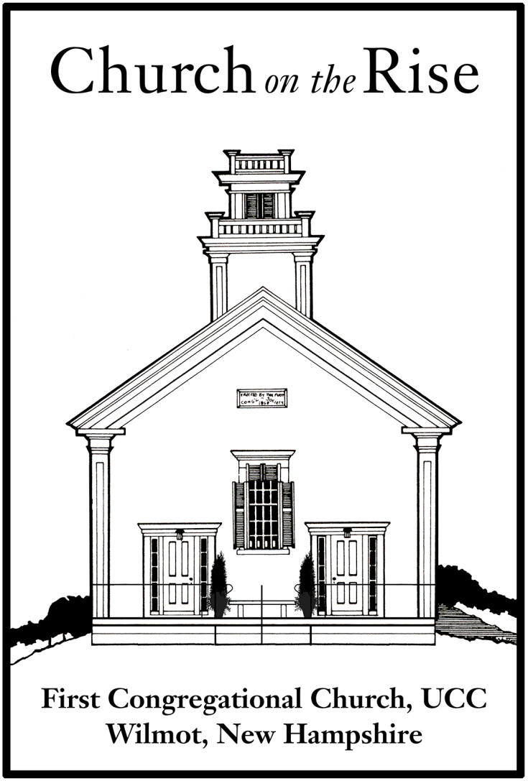

No matter who you are or where you are on your life’s journey, you are welcome in this Open and Affirming congregation of the United Church of Christ.

`
Order of Service for

Sunday, January 17, 2021

Minister: Rev. Sara Marean
Music Director: William Ogmundson

ORDER of WORSHIP – January 17, 2021

Words of Welcome and Announcements
Introit
A Time of Silence to Center Ourselves

Words from the Bible and from Dr. King
Reader 1: “By the waters of Babylon, there we sat down and wept when we remembered Zion. . . . For there our captors required of us songs, and our tormentors, mirth, saying, ‘Sing us one of the songs of Zion.’” (Psalm 137:1, 3)
Reader 2: “I have stood in a meeting with hundreds of youngsters and joined in while they sang “Ain’t Gonna Let Nobody Turn Me Round.” It is not just a song; it is a resolve. . . . These songs bind us together, give us courage together, help us march together.” (MLK, “Why We Can’t Wait”)
Congregation: For the power of songs and songs of power, we give you thanks, O God.

Reader 1: “You have heard that it was said, ‘You shall love your neighbor and hate your enemy.’ But I say to you, love your enemies and pray for those who persecute you, so that you may be children of your Father [and Mother] in heaven; for God makes the sun rise on the evil and on the good, and sends rain on the just and the unjust.” (Matthew 5:43–44)
Reader 2: “Let us therefore not think of our movement as one that seeks to integrate into all the existing values of American society. Let us be those creative dissenters who will call our beloved country to a higher destiny, to a new plateau of compassion, to a more noble expression of humanness.” (MLK, “Where Do We Go from Here?”)
Congregation: For your realm, which stands beyond and against all nations, and your justice, which judges all people, we give you thanks, O God.

Reader 1: “Cain said to his brother Abel, ‘Let us go out to the field.’ And when they were in the field, Cain rose up against his brother Abel, and killed him. Then God said to Cain, ‘Where is your brother Abel?’ He said, ‘I do not know; am I my brother’s keeper?’ And God said, ‘What have you done? Listen; your brother’s blood is crying out to me from the ground!’” (Genesis 4:8–10)
Reader 2: “The person who passively accepts evil is as much involved in it as the one who helps perpetrate it. The person who accepts evil without protesting against it, is really cooperating with it.” (MLK, “Stride toward Freedom,” adapted)
Congregation: For the continuing witness of the life and ministry of the Reverend Dr. Martin Luther King Jr., whose blood cries from the ground to you and to us, we give you thanks, O God.

Hymn Lift Every Voice and Sing Chalice #631
Lift every voice and sing, till earth and heaven ring,
Ring with the harmonies of liberty,
Let our rejoicing rise high as the listening skies,
Let it resound loud as the rolling sea.
Sing a song full of the faith that the dark past has taught us;
Sing a song full of the hope that the present has brought us;
Facing the rising sun of our new day begun, let us march on till victory is won.

Stony the road we trod, bitter the chastening rod,
Felt in the days when hope unborn had died;
Yet with a steady beat, have not our weary feet
Come to the place for which our people sighed?
We have come over a way that with tears has been watered;
We have come, treading our path thru the blood of the slaughtered,
Out from the gloomy past, till now we stand at last
Where the white gleam of our bright star is cast.

God of our weary years, God of our silent tears,
Thou who hast brought us thus far on the way.
Thou who hast by thy might led us into the light,
Keep us forever in the path, we pray.
Lest our feet stray from the places, our God, where we met thee;
Lest our hearts drunk with the wine of the world, we forget thee;
Shadowed beneath thy hand, may we forever stand,
True to our God, true to our native land.

Prayer of Confession
O God, we long to co-create with you the Beloved Community
which looks to the common good; privileges all equally,
and creates societal systems
which celebrate the humanity and the gifts of all.
And yet we focus on our differences, envy each other’s gifts,
devalue manifestations of you, O God, that are not like our own.

Perhaps our sin is a slow wait for justice:
We allow the voices of brothers and sisters
who do not look like us, love like us, or worship like us to be silenced.
We have told them to wait for freedom, justice and equality.
We foster in them a denigrating sense of nobodiness. Lord, have mercy.

Or perhaps we have kept silence ourselves
in the face of their struggle for full human life.
For it is not solely hateful words and actions,
but also appalling silence that follows the path of oppression. Christ, have mercy.

Perhaps our sin is to give in to weariness, discouragement, bitterness:
You have called us to be drum majors for justice, peace and righteousness,
Yet the work of peace and justice overwhelms us at times,
To build with God the Beloved Community seems impossible,
and we grow weary.
We cry, “Peace, peace,”
but there is no peace within us or around us.
We find ourselves on the path
of hatred and oppression, violence and war. Lord, have mercy.
Silence
Assurance of Pardon
Sisters and brothers, God is at work in us and with us!
God has promised:
“I will not keep silent and I will not rest
until the vindication of my beloved people
shines out like the dawn and their salvation like a burning torch.
My people shall no more be termed ‘forsaken’
and their land shall no more be termed ‘desolate.’”
We remember that you have given your Beloved people a new name:
“My delight is in them.”

Thank you, God for delighting in us even now,
for forgiving us our slow action, our silence and our weariness,
for empowering our work
and inviting us once again
to create with you the Beloved Community you long for. Amen.

Message Rev. Sara Marean

Hymn Precious Lord, Take My Hand Chalice #628
Precious Lord, take my hand, lead me on, let me stand,
I am tired, I am weak, I am worn;
Through the storm, through the night, lead me on to the light:
Take my hand, precious Lord, lead me home.

When my way grows drear, precious Lord, linger near,
When my life is almost gone,
Hear my cry, hear my call, hold my hand lest I fall:
Take my hand, precious Lord, lead me home.

When the darkness appears and the night draws near,
And the day is past and gone,
At the river I stand, guide my feet, hold my hand:
Take my hand, precious Lord, lead me home.

MORNING PRAYERS
Sharing of Joys and Concerns
Pastoral Prayer followed by The Lord’s Prayer
Our * …. who art in Heaven, hallowed be Thy name. Thy kingdom come, Thy will be done, on earth as it is in Heaven. Give us this day our daily bread, and forgive us our debts as we forgive our debtors. Lead us not into temptation, but deliver us from evil. For Thine is the kingdom, the power, and the glory forever. Amen
*We have come to know God by many different names and images. Please use the one which speaks from your heart today. (e.g. Father, Mother, Creator…)

Prayer Response Hymn #658 Restless Weaver (Verse 4)
Restless Weaver, still conceiving new life now and yet to be.
Binding all your vast creation in one living tapestry.
You have called us to be weavers. Let your love Guide all we do.
With your Reign of Peace our pattern, we will weave your world anew.

THE GIVING OF OUR GIFTS
Invitation and Offertory
Response (Tune: “For the Beauty of the Earth”)
As they offered gifts most rare, at the manger rude and bare,
So may we with holy joy, pure and free from sin’s alloy,
All our costliest treasures bring,
Christ, to you from whom they spring.
Prayer of Dedication
O God, we commit to use all our gifts
--wisdom, knowledge, faith, healing,
working of miracles, prophecy, discernment,
tongues, administration, hospitality,
and finances--
in the service of acting as co-workers
with you and each other
for peace and justice to flow like a mighty stream. Amen.

Closing Hymn “We Shall Overcome” Chalice #630
We shall overcome, we shall overcome, we shall overcome someday!
Oh, deep in my heart, I do believe we shall overcome someday!

We are not afraid, we are not afraid, we are not afraid today!
Oh, deep in my heart, I do believe we are not afraid today!

We shall live in peace, we shall live in peace, we shall live in peace someday!
Oh, deep in my heart, I do believe we shall live in peace someday!

COMMISSIONING ONE ANOTHER
Go into the world to serve God with gladness; be of good courage; hold fast to that which is good; render to no one evil for evil; strengthen the faint-hearted; support the weak; help the afflicted; honor all people; love and serve God, rejoicing in the power of the Holy Spirit. Amen.

BENEDICTION and SUNG RESPONSE “Alleluia!”

Phrases from the speeches of Martin Luther King, Jr. have been woven into the prayer texts. They are identified by italics. Texts of King’s work are available in A Testament of Hope: The Essential Writings of Martin Luther King, Jr., edited by James M. Washington; © 1986 Coretta Scott King. A brief essay on King’s understanding of the term “Beloved Community” is available at http://www.wilpf.org/mlksbelovedcommunity

