Contents

Navigation – How to Get Around the Worksheet 1

Screen Areas 1

Menu Bar 1

Help 2

Spreadsheet Data 3

Active Cell 3

Active Cell Reference (Name Box) 3

Select All Box: 3

Zoom Control 4

Scroll Bars 4

Scrolling: 4

Sheet Tabs 4

Undo 5

Descriptions by Column 6

Title 6

Description 6

Author(s) 6

Book Club Discussion 6

Added to List 7

UCC List 7

NY Times List 7

Boston Globe List 7

ESA List 7

Huffpost List 7

Social Justice List 7

Recommendation 7

Publication Year 7

Prose/Non-fiction/Poetry 7

ISBN 7

DDC 7

DDC Description 7

Author of Color 7

Male/Female Author 7

# of Pages 7

Amazon Star Rating 7

Kindle $ 7

Kindle Unlimited 8

Paperback $ 8

Audible $ 8

Narrator 8

Author’s website / wiki 8

Guides 8

Data Manipulation 9

Sorting – Step by Step 9

QuickSort: 9

Custom Sort: 11

Custom Sort: 12

Filtering – Step by Step 13

Finding – Step By Step 17

Presentation 18

Hiding Columns – Step By Step 18

Printing 18

Keyboard Shortcuts 19

Display the Book Description (a Comment): 19

Filter: 19

Find: 19

Help: 19

Hide Selected Row 19

Hide Selected Column: 19

Make Different Spreadsheets Active: 19

Return to Home Menu: 19

Scroll Left: 19

Scroll Right 19

Scroll Up: 19

Scroll Down: 19

Select All: 19

Sort: 19

Undo: 19

# Navigation – How to Get Around the Worksheet

## Screen Areas

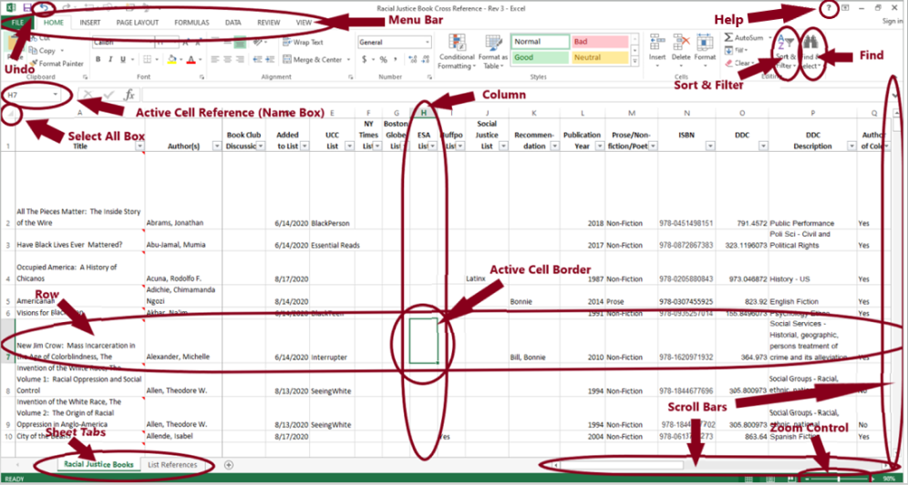

Menu Bar:



This example may have different Menu Items based on your version of and options installed for Excel. In this case it contains File, Home, Insert, Page Layout, Formulas, Data, and Review. Each menu displays different options directly below it on the Ribbon. In this case the options displayed are for the **Home** Menu, which will be used throughout most of this guide.

To move between different menus, you can either click on their names, or you can press the **<ALT>** key followed by **F** for File or **H** for Home or **N** for Insert or **P** for Page Layout, etc.



Navigation – How to Get Around the Worksheet – cont’d

Screen Areas – cont’d

## Help

Press the **?** button in the Application Control Section in the upper right of the screen.



Alternatively, you can press **F1**.

You’ll be presented with a screen that allows you to enter search criteria.

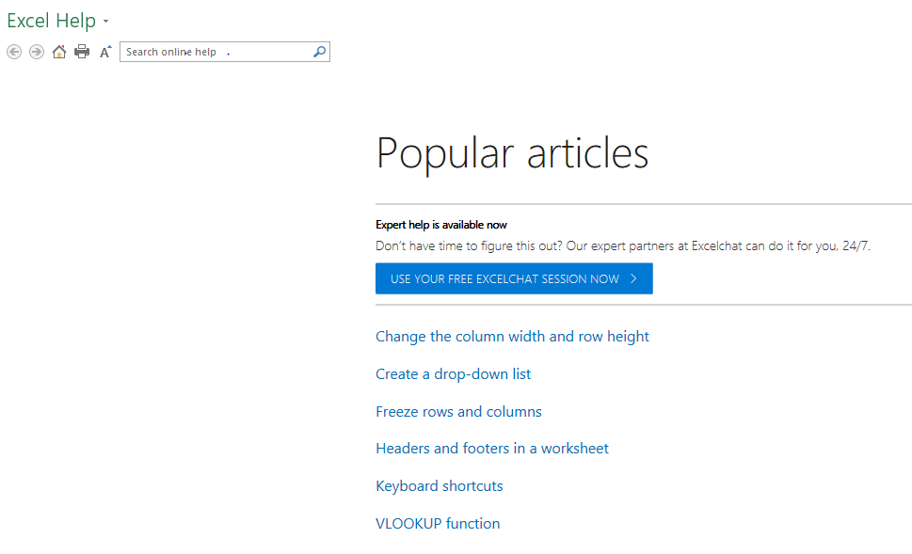

Enter what you would like to learn more about (i.e. filter) and press **Enter**. You will be presented with a wide selection. If you would like to have more of a general overview, enter **tutorial**, and then select **Excel for Windows training**.

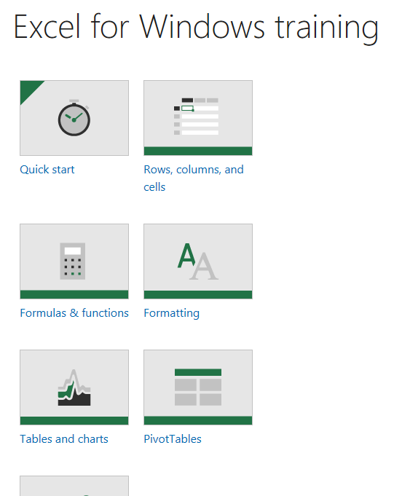

Navigation – How to Get Around the Worksheet – cont’d

Screen Areas – cont’d

Spreadsheet Data:

Data is organized in **rows** and **columns**. Each Racial Justice Book has its data within one row, beginning on row 2. Titles for the columns appear in row 1. Descriptions by Column are found below.

Active Cell:

This is the row/column confluence highlighted with the **Active Cell Border**.

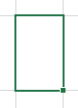

Active Cell Reference (Name Box):

Displays (H7) in Column (in this case H), and Row (in this case 7) format.



Select All Box:



When you click on this box with your mouse, the entire spreadsheet is selected. Visually, you will see the whole worksheet high-lighted.

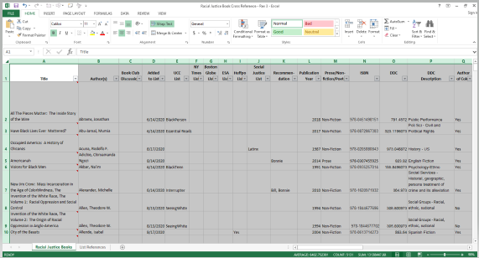

Alternatively you can simultaneously press the **<CTRL> + A**.

Navigation – How to Get Around the Worksheet – cont’d

Screen Areas – cont’d

Zoom Control: (Make letters bigger (zoom in) /smaller (zoom out))



Click on the **+ button** on the zoom control to zoom in or the **– button** to zoom out.

Alternatively, click on the **vertical bar** on the slider and move it right to zoom in or left to zoom out.

Another option is to hold the **<CTRL> key** while using the **Mouse Scroll Wheel.**

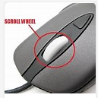

Scroll Bars: (Move up/down or left/right within the spreadsheet)



Click your mouse on the **horizontal slide bar** and move the bar to the right or left (or up and down on the horizontal scroll bar).

Alternatively click on the **arrows**, or the **grey area** to the right or left of the vertical slide bar.

## Scrolling:

There are multiple options to move around the worksheet.

1. Use the **Scroll Bars**. This does not affect the **Active Cell**.
2. Use the **Mouse Scroll Wheel**. This does not affect the **Active Cell**.
3. Move the Mouse Scroll Wheel forward/backward to go up/down.
4. Hold the Mouse Scroll Wheel down and move the Mouse to the right/left.
5. Use the **Arrow Keys** to move from cell to cell. This will affect the **Active Cell**.
6. Use the **<Page Up>** / **<Page Down>** Keys to move up/down. Simultaneously press **<ALT> key + <Page Up>** to move left, **<ALT> + <Page Down>** to move right. This will affect the **Active Cell**.

## Sheet Tabs



Multiple Spreadsheets can be contained within one Worksheet. To move from sheet to sheet, click on each tab with your mouse, or press **<CTRL> key** + **<Page Down>** to move to the spreadsheet on the Right, and **<CTRL> key** + **<Page Up>** to move to the spreadsheet on the Left.

# Undo



If you accidentally enter something, you can reverse your entry by clicking on the **Undo button** on your Quick Access Bar. In this example the Quick Access Bar is in the upper left corner, but it can be located elsewhere.

# Descriptions by Column

## Title

Title of the Book. Embedded within this cell is also the book description.

## Description

You’ll see a little red triangle in the upper right corner of the cell.

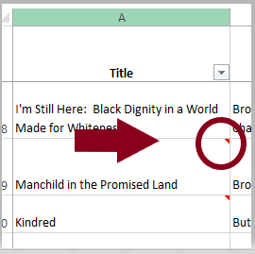

If you hover over that little red triangle (move the mouse over it, don’t click), you will get a pop-up with the description:

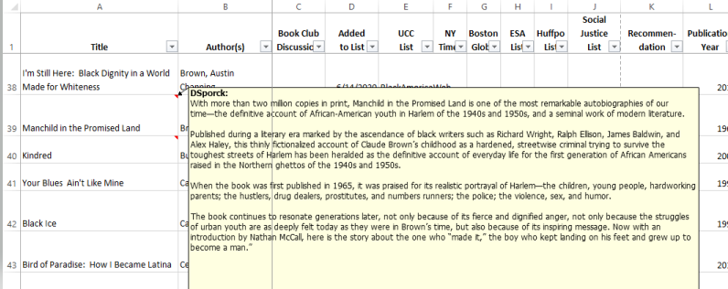

Alternatively, you can see the description by sequentially pressing **<ALT>** then **R** then **V**. Note: this action will take you off the home menu. Press **<ALT>** then **H** to return to the Home Menu.

## Author(s)

Author(s). AKAs are in parenthesis. For Indigenous Authors, their Tribe is in parenthesis.

## Book Club Discussion

If a book was discussed in book club, the date(s) of discussion are listed.

Descriptions by Column – cont’d

## Added to List

Date the book was added to the list.

## UCC List

Yes = Book was directly referenced in NH Conference UCC [Process of Becoming a Racial Justice Church](http://nhcucc.org/uploads/documents/conference-ministries/justice-witness-ministry/Racial%20Justice/Process%20for%20Becoming%20a%20Racial%20Justice%20Church.pdf), or was contained within a list referenced by same document.

## [NY Times List](https://www.nytimes.com/2020/06/05/books/antiracism-books-race-racism.html)

Books on Racism. Suggested by Nan.

## [Boston Globe List](http://view.email.bostonglobe.com/?qs=b380f2a934f63cebdbea057db32e4ff04c493ee63d2a962086d91a14c96bd4081161abb2d7f8e63b9f32dc690718fe6ce78b8f47a59f9fc9c828ffc67571ed6020af18781cb411b0a9cb7022381a17487f21fc797134f052)

Books written by Black Americans. Suggested by Beth.

## [ESA List](https://www.evangelicalsforsocialaction.org/racial-justice/25-books-indigenous-authors-reading/)

Books by Indigenous Authors.

## Huffpost List

Books by Latinos.

## Social Justice List

[Afro-Latinx](https://socialjusticebooks.org/booklists/afro-latinx/)

[Asian-Americans](https://socialjusticebooks.org/booklists/asian-americans/)

[Environment](https://therevelator.org/environmental-justice-books-june-2020/)

[Latinx](https://socialjusticebooks.org/booklists/latinx/)

## Recommendation

Individual who mentioned the book.

## Publication Year

Original year published, regardless of edition

## Prose/Non-fiction/Poetry

Non-Fiction, with Fiction broken down to Prose, Poetry, and possibly Drama in the future.

## ISBN

International Standard Book Number

## DDC

Dewey Decimal Classification based on [OCLC](http://classify.oclc.org/classify2/ClassifyDemo?&startRec=0). If you sort by this column, you will get your books in order as seen in the library.

## DDC Description

Description of the Dewey Decimal Classification.

## Author of Color

## Male/Female Author

## # of Pages

Based on Kindle version if available

## Amazon Star Rating

1-5 Rating (5 being the best).

## Kindle $

Cost at Amazon for Kindle Version at time of data collection.

Descriptions by Column – cont’d

## Kindle Unlimited

Availability of book as part of Kindle Unlimited

## Paperback $

Cheapest cost of paperback on Amazon at the time of data collection.

## Audible $

Cost of audible version on Amazon at the time of data collection

## Narrator

Narrator of the audible version

## Author’s website / wiki

Author’s website or foundation’s website. If none found, Wikipedia reference cited.

## Guides

Discussion guide when found from author, foundation, or publisher.

# Data Manipulation

## Sorting – Step by Step

The Racial Justice Book Cross Reference has been distributed sorted by Author and then Title. You can sort the data by any column or combination of columns.

QuickSort:

First, place your cursor anywhere in the **column** by which you wish to sort. Confirm by verifying either the Active Cell Border or the Active Cell Reference. On the Home Menu, press the **Sort & Filter** button. Alternatively, press **<ALT>** then **H** then **S**.



Then press the  button to **Sort Smallest to Largest** or button to **Sort Largest to Smallest**. If using the keyboard, press the underlined letter (**S** or **O**).

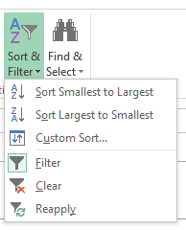

In the following example, the cursor was placed in cell L2 (Publication Year Column), and pressed the Sort Smallest to Largest button

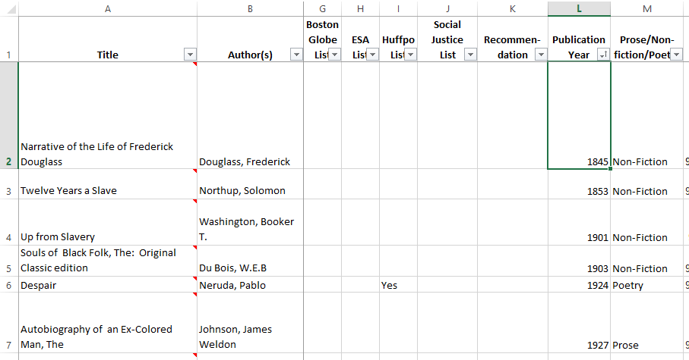

Data Manipulation – cont’d

Sorting – Step by Step - cont’d

QuickSort – cont’d

Note the Sort/Filter Dropdown in L1 now shows the Up Arrow.

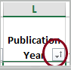

You may want to consider using the Undo function once you have reviewed your data before proceeding further.

In the following example, the cursor was placed in cell **D2** (Added to List), and pressed the **Sort Newest to Oldest** button. Note, because this is a date field, Excel renames the button from Largest to Smallest to Newest to Oldest.

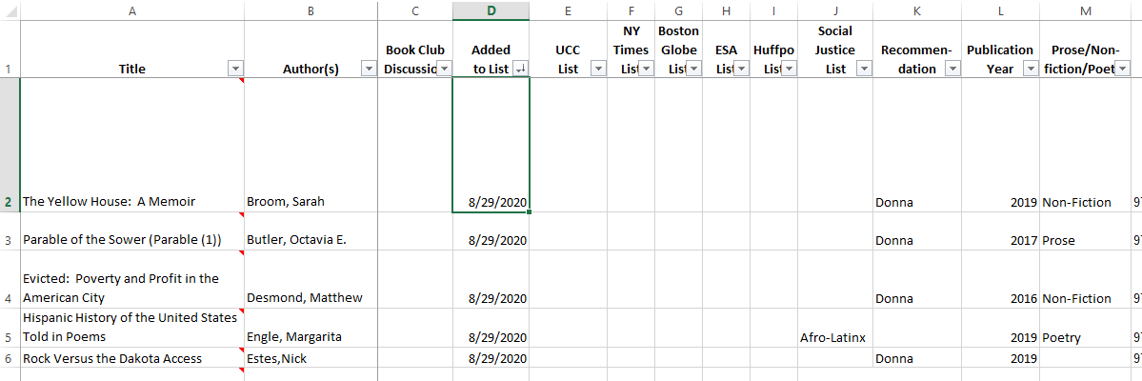

The Sort/Filter now displays a Down Arrow.

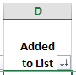

Again, you may want to consider using the Undo function once you have reviewed your data before proceeding further.

Data Manipulation – cont’d

Sorting – Step by Step - cont’d

Custom Sort:

It does not matter where the Active Cell is when using a Custom Sort. To begin, on the Home Menu, press the **Sort & Filter** button. Alternatively, press **<ALT>** then **H** then **S**.



Then press the  button to **Custom Sort.** If using the keyboard, press the underlined letter (**U).**



A pop-up window will appear. Be sure the **My data has headers** is checked off.

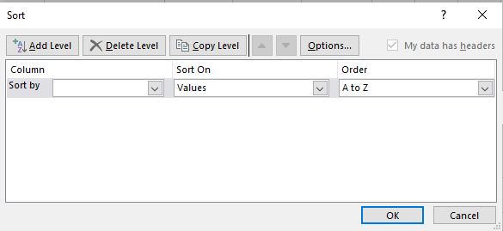

Press the **down arrow** next to the **Sort by Field**. Alternatively, use the tab key until the Sort by Field is highlighted, and then press F4.



Sorting – Step by Step - cont’d

Custom Sort:

This will present you with a pull-down list. In this example DDC Description was selected.

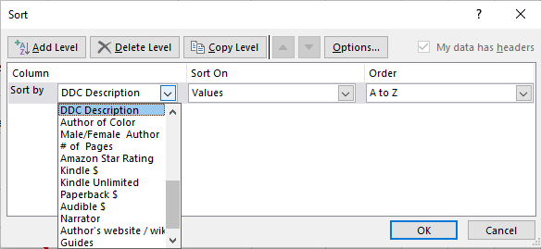

To add addition sort criteria, press the  button. Alternatively, press **<ALT>** + **A.** In this example both Author and Title were added.

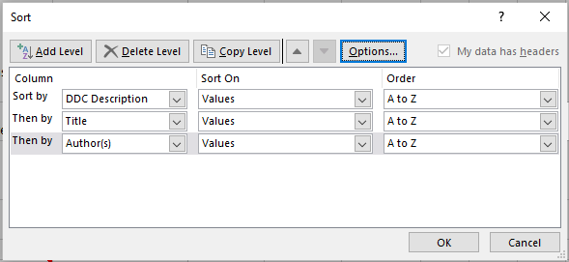

Press **OK** to view results.

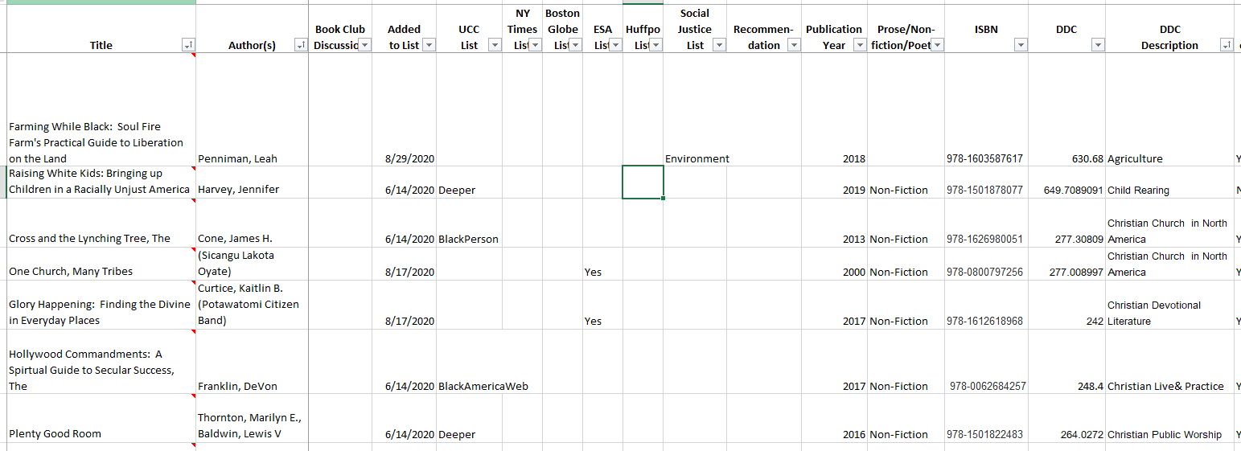

## Filtering – Step by Step

Filtering is one of the more powerful features to be discussed. It enables you to quickly find/analyze the data. The following Step by Steps will take you through several questions asked and answered using this feature.

For all questions, they begin by pressing the **pull-down** button in the header (row 1) of a specific column. Alternatively, once in the cell, one can simultaneously press <**ALT**> + **Down Arrow** key.

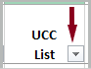

These questions were selected as examples to demonstrate the different capabilities of the filter function.

Question 1: What books were recommended by the NH UCC?

Once you press the filter, you will see the following pull-down:

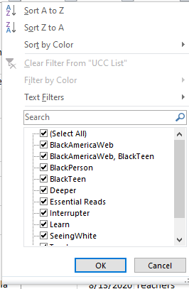

Filtering – Step by Step - cont’d

Question 1: What books were recommended by the NH UCC? – cont’d

Scroll to the end and **uncheck the (Blanks) selection**. Then press the **OK** button.

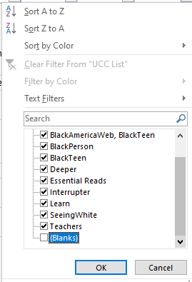

The results are displayed. At the bottom of the screen it lets you know how many rows meet the criteria (163 of 279).

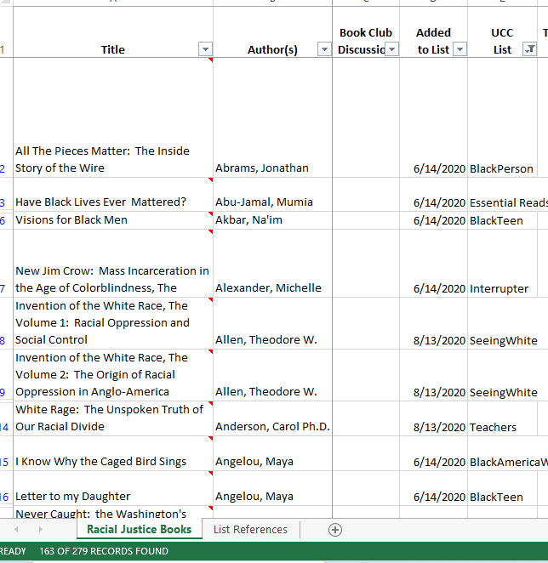

You may want to undo before starting you next analysis.

This same concept can be used to determine which books appear on any of the lists in columns E through J.

Filtering – Step by Step - cont’d

Question 2: Which of Toni Morrison’s books are on the list?

Press the **Filter pull-down** in the Author column. Begin typing Morrison in the Search field until on Toni Morrison appears.

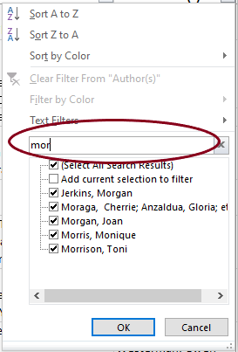 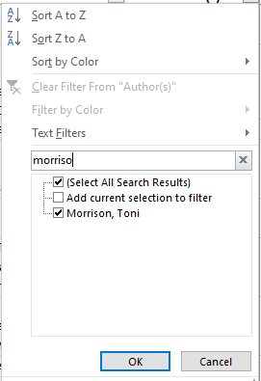

Press the **OK** button. The following results display.

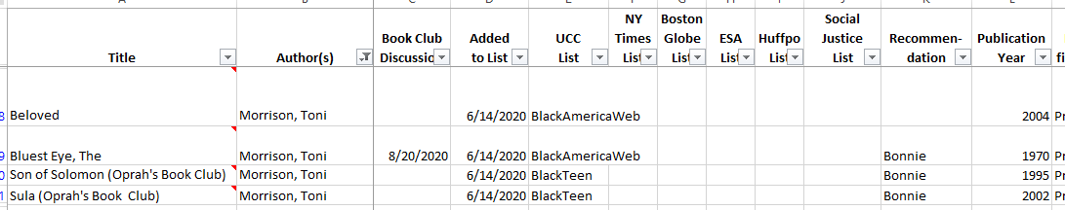

You can use this same concept in Column J (Social Justice List) to determine which books relate to Afro-Latinx or Asian Americans or Latinx or the Environment.

Filtering – Step by Step - cont’d

Question 3: Which books were published since 2017?

Press the **Filter pull-down** in the Publication Year column.

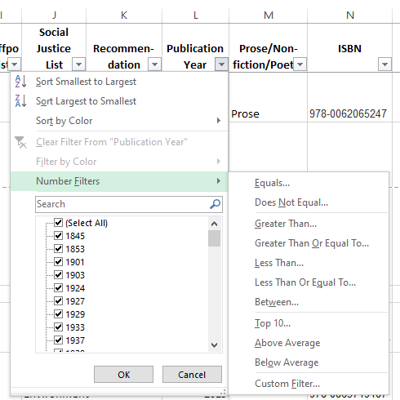

Click on **Number Filters** and then **Greater Than Or Equal To…** A pop-up will appear.

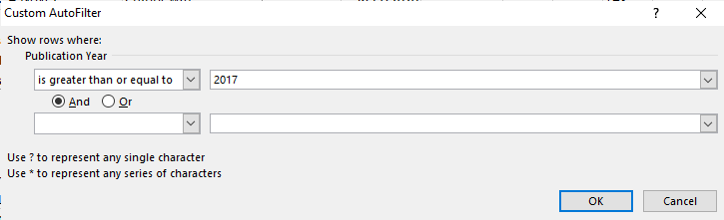

Enter **2017** and press the **OK** button. The following results display. (Note 86 books are identified).

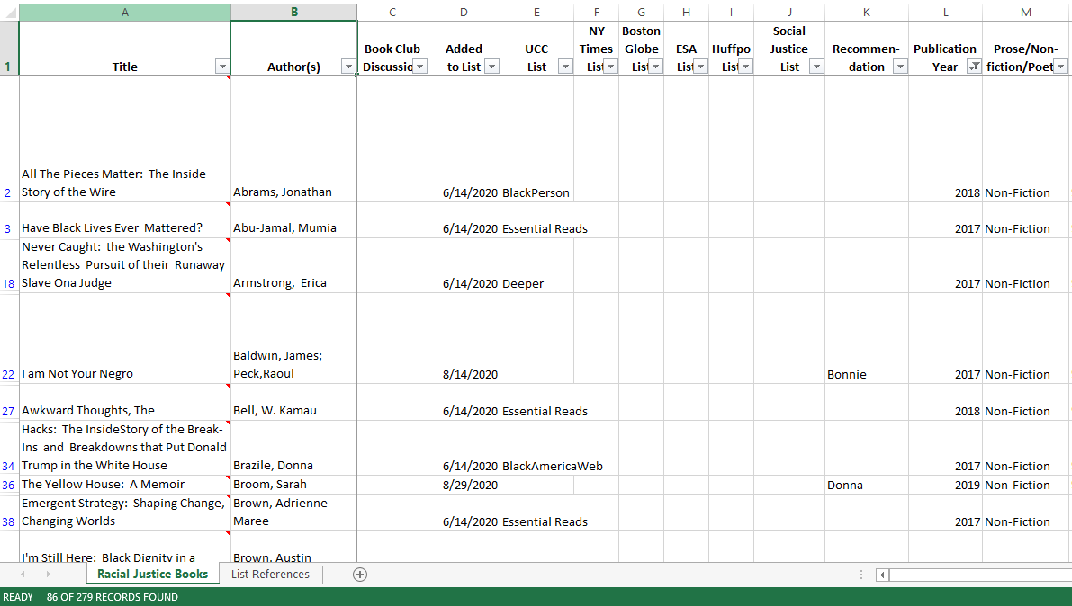

Filtering – Step by Step - cont’d

Question 4: Which books were written by Female Authors of Color?

Filter first by Authors of Color (uncheck No) and then Male/Female (uncheck Male). In other words, **filter the previously filtered list**. Note: for both of these columns there is an option for both. Where multiple authors occur, they may differ in race and sex. Consequently, this may not be 100% accurate, but you can review the Both to see if you wish the book to be included.

## Finding – Step By Step

To find a word / a fragment of a word, it is sometimes easier to use the Find function. Press the **Find & Select** Button on the Home Menu. Then select **Find…**  from the submenu.

 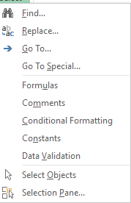

Alternatively, press **<CTRL>** + **F**.

In this example standing was entered in the search field.

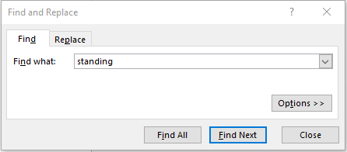

Results included Titles that contained standing, as well as an Author from the Standing Rock Sioux tribe.

# Presentation

## Hiding Columns – Step By Step

**Right Click** on the column letter to highlight a column and display the column action menu.

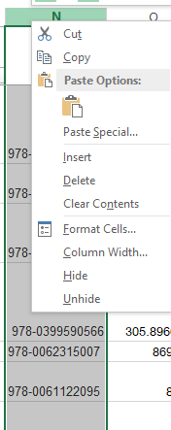

Select Hide to hide the column. Note: Column N no longer appears on the screen.

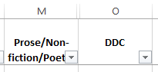

# Printing

At 279 rows, the current spreadsheet takes 96 pages to print. A list of just the Titles with Authors is 10 pages. For the environment, you are encouraged to view the data on your computer or mobile device.

# Keyboard Shortcuts

Display the Book Description (a Comment): **<ALT>** then **R** then **V**

Filter: <**ALT**> + **Down Arrow** key

Find: **<CTRL> + F**

Help: **<F1>**

Hide Selected Row: **<CTRL> + 9**

Hide Selected Column: **<CTRL> + 0**

Make Different Spreadsheets Active: **<CTRL> key** + **<Page Up>** (Spreadsheet to Left) or **<CTRL> key** + **<Page Down>** (Spreadsheet to Right)

Return to Home Menu: **<ALT>** then **H**

Scroll Left: **<ALT> + <Page Up>**

Scroll Right: **<ALT> + <Page Down>**

Scroll Up: **<Page Up>**

Scroll Down: **<Page Down>**

Select All: **<CTRL> key + A**

Sort: **<ALT>** then **H** then **S**.

Undo: **<CTRL>** key + **Z**